Developing rubrics as part of an evaluative approach to assessing value for money
NT AES Professional Learning Seminar, 24 January 2019, The Fred Hollows Foundation Board Room, presented by Nea Harrison, Pandanus Evaluation
The session will guide participants through the process of setting criteria and standards to guide program evaluation and value for money assessment. We will briefly look at how rubrics have been used for evaluating complex social programs, and how they can be used with or without economic approaches to assess value for money. We will then work through the process of developing a rubric.

What is Value for Money assessment?
Frameworks for assessing Value for Money (VfM) emphasize the importance of using limited funds as effectively as possible to achieve change for poor or marginalised people and to demonstrate value to investors.
VfM is often assessed using the criteria of economy (less cost, while bearing in mind quality), efficiency (achieving outputs for inputs, while bearing in mind quality), effectiveness (achieving program outcomes, while bearing in mind equity), and equity (ensuring that benefits are distributed equally). DFAT has developed eight VfM Principles using this criteria to guide decision making and maximise the impact of its investments.
There are a range of VfM approaches. Cost Benefit Analysis and Social Return on Investment monetise outcomes; Cost Effectiveness and Cost Utility Analysis compare alternative programs; and Basic Efficiency Resource Analysis and Rank Correlation of Cost vs Impact compare a number of programs.
VfM approaches used by social development programs often focus on more qualitative measures and generally include the development a VfM assessment rubric that aligns with the program’s Theory of Change. An evaluation specific approach, using criteria and standards, is compatible with the Four Es (Economy, Efficiency, Effectiveness and Equity), and provides a way to synthesize mixed methods evidence which may include economic, quantitative and qualitative data.

What is a rubric?
A rubric is a monitoring and evaluation tool that clearly sets out criteria and standards for assessing different levels of performance. It provides an evaluative description of what good, excellent (etc) quality; value or performance would look like in practice. It allows for interpretation of qualitative, quantitative and mixed method data. Rubrics provide way to synthesize evidence into an overall evaluative judgement about a project overall or components of a program or project.
In my experience, developing a rubric is best done as a collaborative activity with key stakeholders. It involves key stakeholders who know a lot about the context and required outcomes of a project setting standards – or definitions of what should constitute ‘excellent’, satisfactory’, or ‘unsatisfactory’ performance.

Process for developing a rubric
- Get the right people in the room
- Clearly define your criteria (evaluation questions, aspects of focus)
- Decide how many levels you want and the appropriate labels for them
- Brainstorm what distinguishes ‘Excellent’ (Best practice or highly effective) from ‘Poor’ (or ineffective / unacceptable performance)
- Draw boundaries - decide what is out and what is in
- Work through each of the levels

How many levels?
- Depends on the purpose of the rubric. Too few and it is hard to show improvements, too many and it becomes too difficult to distinguish between levels. Levels can be labelled to suit the project.

Some examples of rubrics

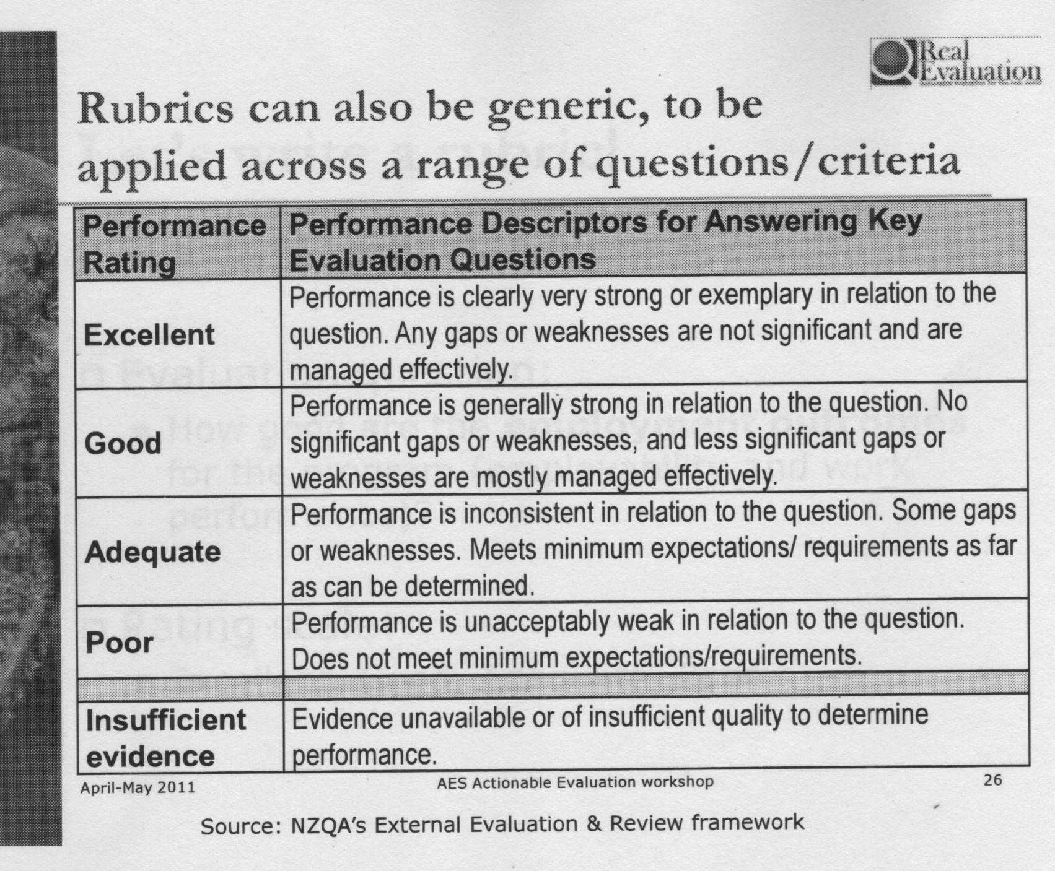
This example of a generic rubric is provided Jane Davidson in her Real Evaluation Blog.

Rubric developed for the Palmerston Tiwi Islands Communities for Children Program
The following example is part of a rubric developed for the Palmerston / Tiwi Islands Communities for Children Program in Australia. The rubric was developed to clarify quality in relation to the key Program outcomes identified in the program logic. It was organised under the key evaluation questions set for the Program. The rubric guided assessment and evaluation activities over the 6-year life of the Program. The rubric was beneficial for helping key stakeholders clearly articulate expected (but usually fuzzy) outcomes such as quality community engagement, community acceptance and ownership, cultural appropriateness, partnership, governance and participation actually involved. It clearly outlined expectations of funded partners and projects.
EXCELLENT (Best practice) | GOOD (Expected) | JUST ADEQUATE (Needs improving) | UNACCEPTABLE
Effectiveness
How effective were Community Partners in encouraging children and families from target groups to participate?
Activity is accessed by a wide range of people from different groups in the community especially hard to engage groups  High level of attendance by all participants  Activity involves and welcomes all members of the family (particularly husbands and children)  Parents and children actively participating in the Activity  High level of enjoyment expressed by participants  Participants take ownership of the Activity though helping organise or conduct activities  Service agreement KPIs are exceeded | Activity is accessed by people from different groups in the community especially hard to engage groups  Good attendance levels with more than 80% of participants attending regularly (80% of time)  Parents and children actively participating in the Activity  High level of satisfaction expressed by participants (more than 80%)_  Participants find the Activity useful  Service agreement KPIs are met | Activity is accessed by people from some groups in the community including hard to engage groups  Average attendance levels with 80% of participants attending regularly (80% of time)  (50%) of Parents and children actively participating in the Activity  Moderate level of satisfaction expressed by participants (more than 70%)  Service agreement KPIs are met | Activity is accessed by people from only one or two groups in the community  No access by hard to engage groups  Poor attendance  Very few participants attend regularly  Participants who are attending are not actively engaged in the Activity  Low levels of satisfaction expressed by more than 30 % of participants  Service agreement KPIs are not met
How effective were the partnerships created?
Partnerships between Community Partners / and or other services have been established and partnership processes documented in formal agreements  Community Partners are working in partnership with community in line with documented processes and or agreements  Partnerships contribute to significantly improved service delivery  Partnership contribute to significantly better access to services for participants | Partnerships between Community Partners / and or other services have been established and partnership processes documented  Community Partners are working in partnership with community in line with documented processes  Partnerships contribute to service delivery  Partnerships support families to navigate the service sector effectively clearly improved | Community Partners communicate and liaise with other services  Some partnerships are evident between CPs and limited number of other organisations  Partnerships contribute to better access for participants | No partnerships are established or low levels of partnership between services

A rubric developed to guide Value for Money assessment
A Value for Money (VfM) rubric and rating scale was developed to guide the 2017 evaluation of the CARE International in PNG Coffee Industry Support Project (CISP). To answer the question “to what extent does CISP demonstrate value for money. The evaluation rubric was developed collaboratively by the Papua New Guinea Australian High Commission Counsellor – Gender and Sports, the CARE Program Director, and the evaluation team during the planning phase of the evaluation. The development of the rubric was guided by the question, ‘For each of the criteria of efficiency, effectiveness, economy, and ethics, what would demonstrate good value for money?’
The answers to this question became the rubric ‘Components.’ The rubric ‘Dimensions’ match the DFAT Value for money four Es. The ‘Domains’ group the Components under key headings that include the DFAT principles. Components were drawn from CISP’s monitoring, evaluation, and learning framework and the Pacific Women draft VfM rubric. All of the CISP evaluation questions were clearly incorporated into the CISP VfM rubric. The rubric included a rating scale to provide a final score for each Dimension.
Excerpt from the Coffee Industry Support Project evaluation rubric

References and links
Davidson, E J. (2005). Evaluation Methodology Basics: the nuts and bolts of sound evaluation. Sage Publications, Thousand Oaks, California.

Davidson, E J. (2014). Evaluative Reasoning, Methodological Briefs: Impact Evaluation 4, UNICEF Office of Research Florence.
Fleming, F. (2013), Evaluation Methods for Assessing Value for Money. Retrieved 9 August 2017
King, J. (2016). Value for Investment: a practical evaluation theory, web page, https://www.julianking.co.nz/downloads/
King, Julian and Guimaraes, L. (2016), Evaluating value for money in international development: the Ligada female economic empowerment programme in Mozambique, in eVALUation Matters/ Third quarter 2016. Retrieved 5 August 2017 from:
http://idev.afdb.org/sites/default/files/documents/files/Evaluating%20value%20for%20money%20in%20international%20development-.pdf
Oakden, Judy, (2013), ‘Evaluation rubric :how to ensure transparent and clear assessment that respects diverse lines of evidence, web page, BetterEvaluation, https://www.betterevaluation.org/en/resource/example/rubrics-oakden
CARE International in PNG Coffee Industry Support Project Mid-term Evaluation Report, (2017) https://pacificwomen.org/resources/png-coffee-industry-support-project-mid-term-evaluation-report-management-response/
BetterEvaluation website provides useful bools and resources on rubrics and value for money frameworks. https://www.betterevaluation.org

Fleming (2013)
Australian Government Department of Foreign Affairs and Trade (Retrieved 2017)
King (2016, pp 59-60)

